WALMART ANALYSIS END TO END PROJECT:

Steps followed for Walmart Analysis:

Step 1: Create an IAM user and generate an Access key using which you can run the python script in Jupyter Lab to upload the csv. Data files to an S3 bucket

IAM USER- arn:aws:iam::337964480109:user/Walmart_Analysis_EtoE_Project_User

Step 2: Created an S3 bucket ‘ivm-walmart-analysis-etoe-project-bucket’ to store the project CSV data files
S3URL-https://ivm-walmart-analysis-etoe-project-bucket.s3.us-east-1.amazonaws.com/data/Walmart_Analysis_Project/

Step 3: Update the python script to point to the new S3 bucket created using the user access key created and run the script

Step 4: Create a snowflake Database, Raw Schema and Gold schema

CREATE OR REPLACE DATABASE WALMART_DB;

CREATE OR REPLACE SCHEMA WALMART_DB.RAW_DATA;

CREATE OR REPLACE SCHEMA WALMART_DB.TRANSFORM_DATA;

CREATE OR REPLACE SCHEMA WALMART_DB.MART_DATA;

Step 5 : Create AWS IAM role with S3 full access using which snowflake storage integration connects to S3

Role- arn:aws:iam::337964480109:role/walmart_Analysis_EtoE_Project_Role

Step 6: Create a Storage Integration between snowflake and S3 bucket –‘WALMART_S3_INT’

STEP 7: Create snowflake file format that can be used in external stage creation –‘MY_CSV_FORMAT’

Step 7: Create an external stage in Snowflake that points to storage integration created above.- ‘WALMART_S3_STAGE’

Step 8: Create a dbt folder ‘dbt_Walmart_Analysis_EtoE_Project’ under models specific to this project and create a dbt model to load s3 csv data to raw schema tables.

DBT_ GIT Hub- Repo link:
https://github.com/Vimmani/DE_Academy_dbt/tree/vimmani-AWSGlue-DBT-Snowflake-Project/models/dbt_Walmart_Analysis_EtoE_Project

Step 9: Provided all the required privileges to DBT role (‘PC_DBT_ROLE’ ) in snowflake for WALMART_DB, RAW_DATA schema and WALMART_S3_STAGE so that dbt models can execute and access the csv data files from snowflake stage and create RAW tables in RAW_DATA Schema.

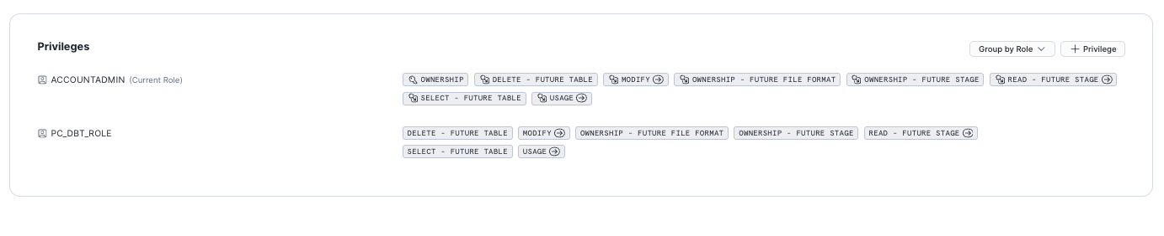

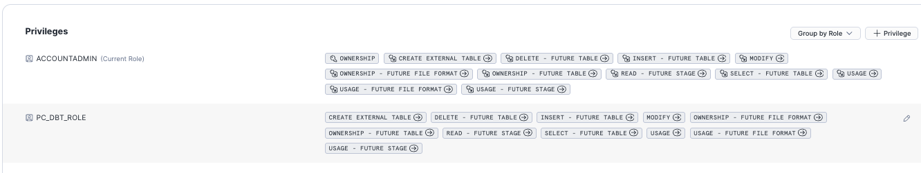

Step 10: Using dbt implemented SCD1(Delete+Insert) for store, date and department dim tables. Also implemented SCD2(dbt Snapshot) for Walmart_fact_table. Below is the lineage generated.

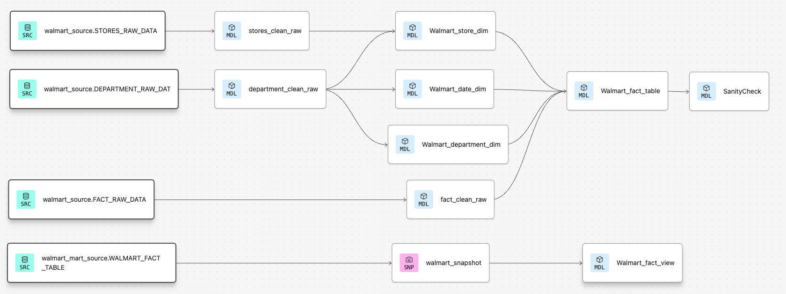

Step 11 : For data analysis I have used snowflake Legacy notebooks by installing Plotly, Streamlit and Python 3.1.0 packages. Then I have written the required queries and generated plotly bars and charts.Attached in GIT Repo

